Limit Switches, Electronics Tray, and LCD Screen

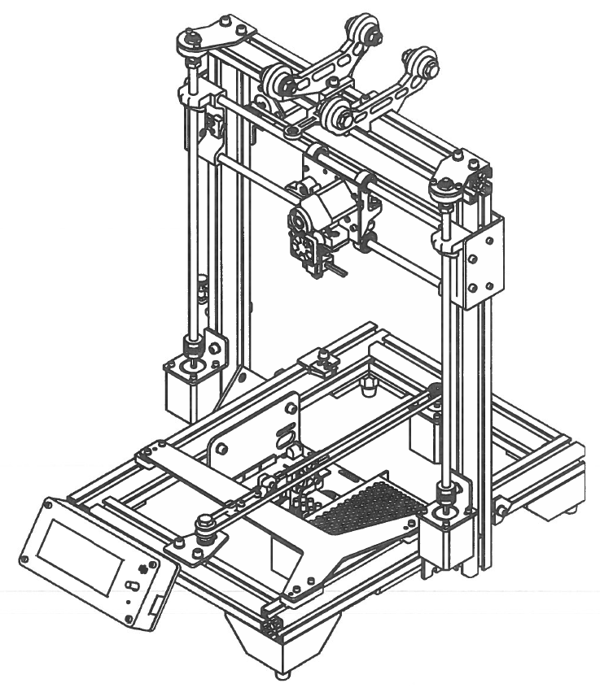

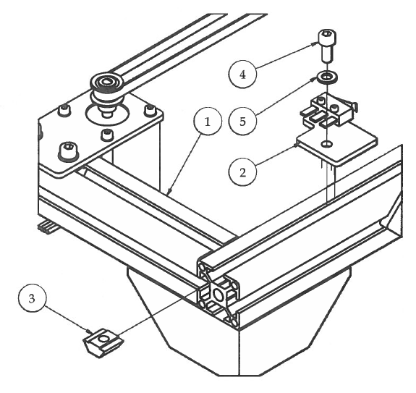Step 1

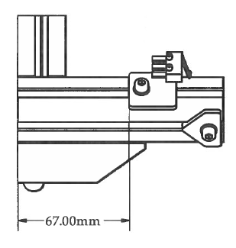

1. Attach the Y Limit Switch sub-assembly using M5 hardware.
2. the Y Limit Switch bracket 67mm from the back of the 3D printer.

|  |  |  |  |
| --- | --- | --- | --- |
| **PARTS LIST** | | | |
| **ITEM** | **QTY** | **PART NUMBER** | **DESCRIPTION** |
| 1 | 1 | X Stage Assembly | Previous sub-assembly |
| 2 | 1 | Y Limit Switch | Previous sub-assembly |
| 3 | 1 | M5 T-Nut | Nuts and bolts |
| 4 | 1 | M5 x 12 | Nuts and bolts |
| 5 | 1 | M5 Washer | Nuts and bolts |
|  |  | M4 Hex Wrench | Tools |

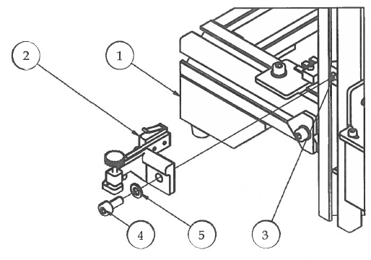Step 2

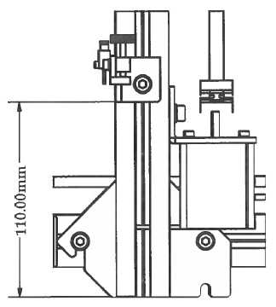

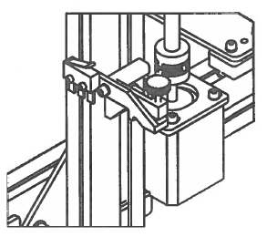

1. Slide M5 T-Nut into the outer slot of the left upright frame.
2. Attach Adjustable Z Limit Switch using M5 hardware measuring 110mm from the bottom of the extrusion. We will calibrate the position of this switch during the final calibration stage of assembly.